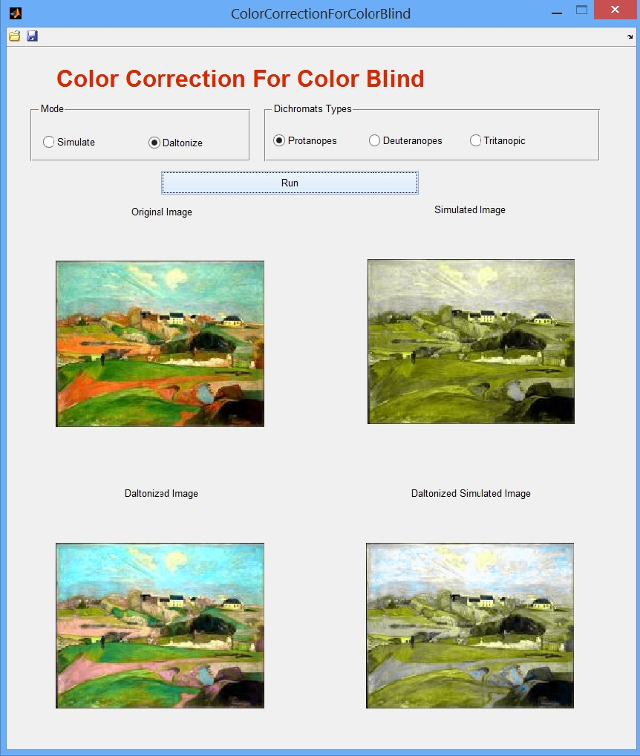

**(3)**

**(7)**

**(6)**

**(4)**

**(5)**

**(1)**

**(2)**

**(8)**

**(9)**

**(10)**

**(11)**

**(1) -** Mode checkbox,

choose between 2 modes:

Simulate mode - simulate image through color blinds eyes.

Daltonize mode - fix image for color blind.

**(2) -** Run button,

In Simulate mode - start simulation.

In Daltonize mode - start daltonization.

**(3) -** Dichromats type checkbox,

choose between 3 types of color blinds.

**(4) -** Original image.

**(5) -** protanopes simulate Image / original simulate Image,

In Simulate mode - simulate image through protanopes eyes.

In Daltonize mode - simulate image through dichromats type

checkbox (3) eyes.

**(6) -** deuteranopes simulate Image / daltonized image,

In Simulate mode - simulate image through deuteranopes eyes.

In Daltonize mode - daltonized image.

**(7) -** tritanopic simulate Image / daltonized simulate image,

In Simulate mode - simulate image through tritanopic eyes.

In Daltonize mode - simulate daltonized image through dichromats type

checkbox (3) eyes.

**(8) -** Open image button,

choose local image to work with.

**(9) -** Save results button,

saves 4 images:

In Simulate mode - screenshot,

protanopes simulation (5),

deuteranopes simulation (6),

tritanopic simulation (7).

In Daltonize mode - screenshot,

dichromats type checkbox simulation (5),

daltonized (6),

dichromats type checkbox daltonize simulation (7).

**(10) -** Minimize.

**(11) -** Close.